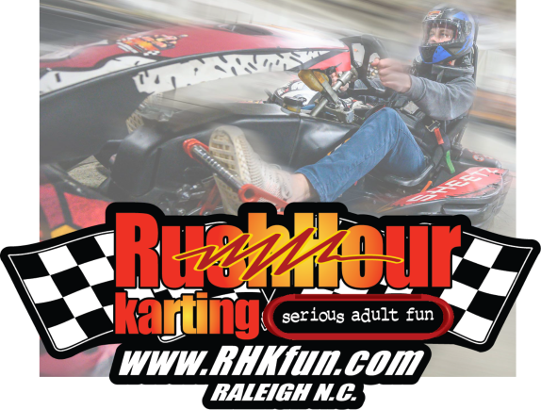
White Oak Business Park
5335 Raynor Road
Garner, N.C. 27529

Ph (919) 662-9101
www.RHKfun.com

RE: COMPANY OUTING & FUN!!!
Date:
Time:
For:
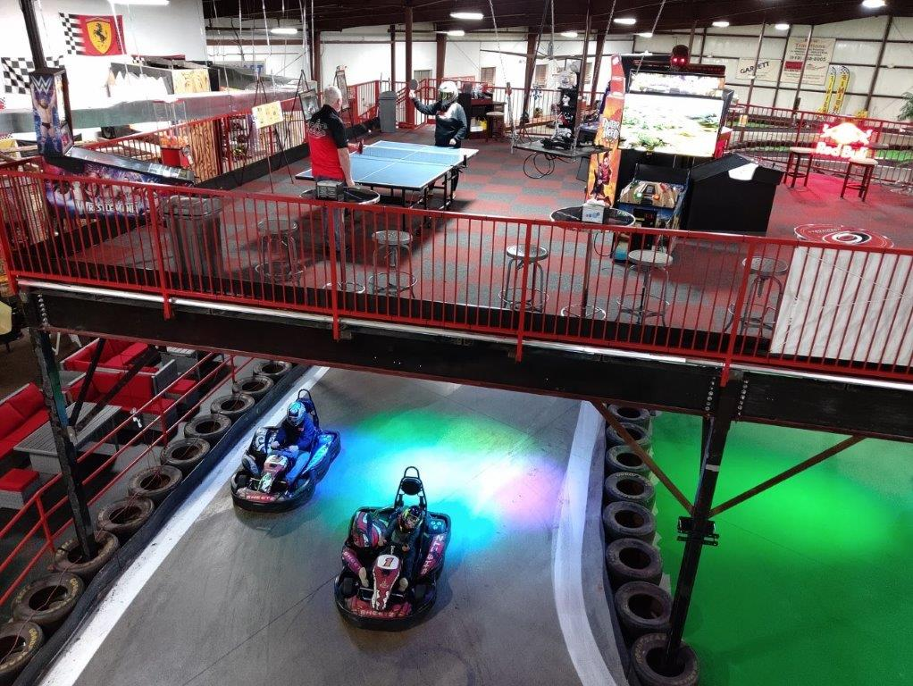
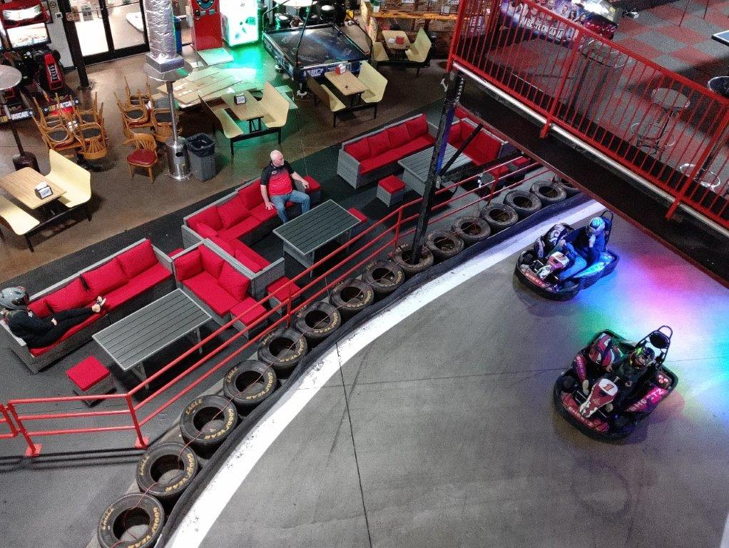
To:
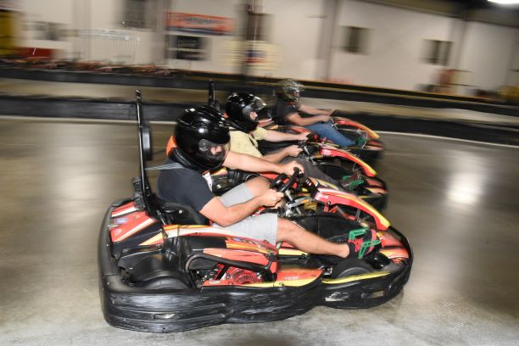

Rush Hour Karting is a High Speed, all Indoor Karting Facility. We have a 1/3 mile Road-Race Track, full of Hair-Pins, Straights, and Sweeping Curves. You jet around this course, with Karts that will go over 40 MPH!

It is all indoor, so come Rain or Shine, the race will go on.

Along with the intense racing, all will eat like Champs in the Sports Bar or the new Mezzanine, overlooking the Race Track. Scrumptious Buffet will be served, with drinks available.

In addition to racing, there are plenty of exciting activities:
- Latest & Greatest Video Games
- Axe throwing
- Rock Wall climbing
- Pool tables & Ping Pong table
- WiFi available everywhere
- Giant TV ‘s for Sports watching
- Comfy & Cozy Cabana-style seating, trackside
- Upstairs Mezzanine for the ultimate race-watching
- Awards podium, for trash-talking & picture-taking
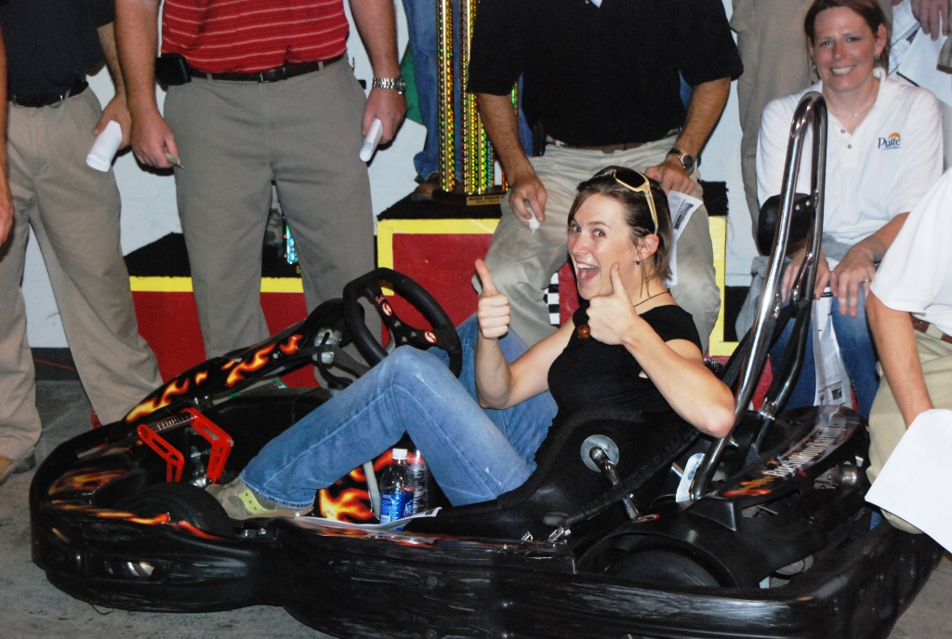
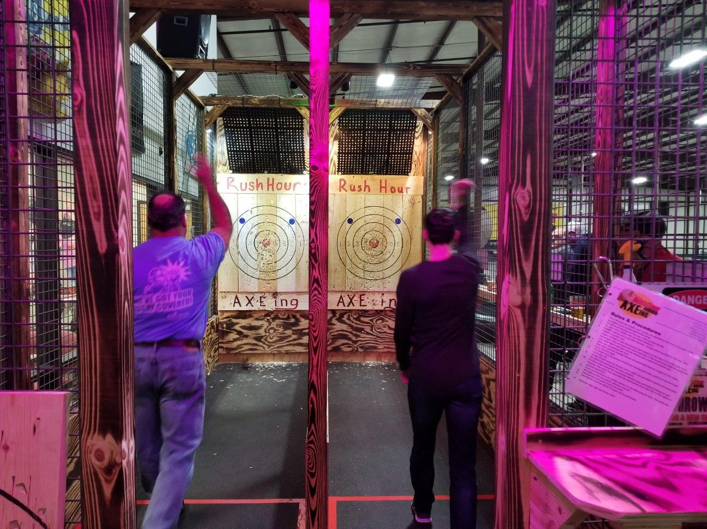

Rush Hour is very easy to get to:
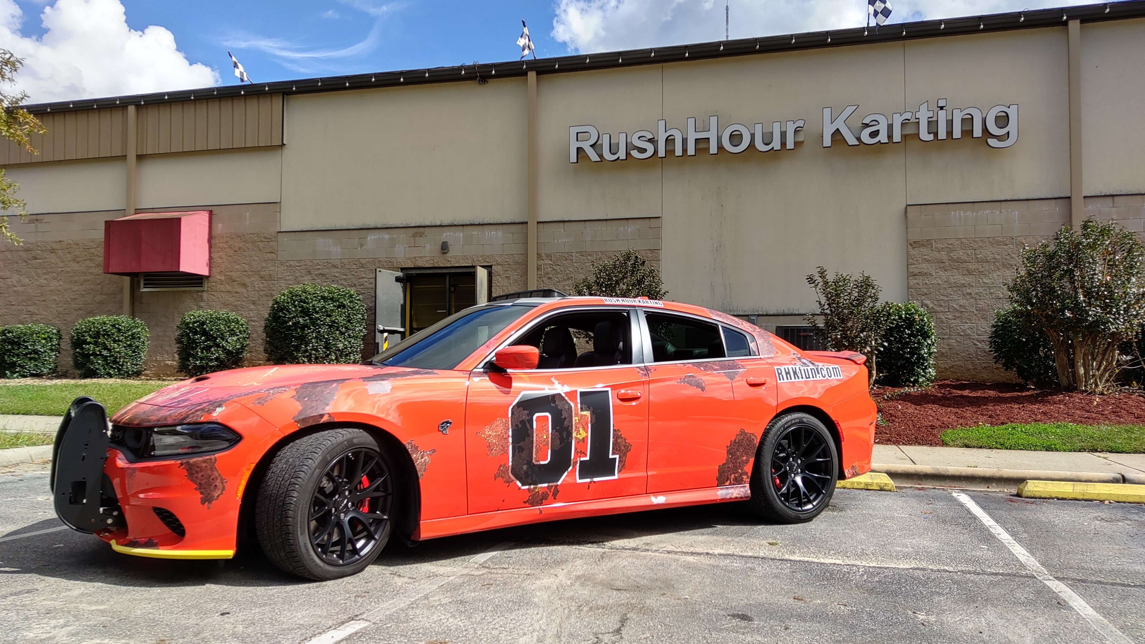
- Take I-40 towards Garner
- Exit 306B “Hwy 7o”, towards Clayton / Smithfield (NOT Garner)
- Right at the 1st Light – Raynor Rd (at Kangaroo Gas Station)
- 1 Mile Down, on Left – Rush Hour Karting

We look forward to seeing you here!

