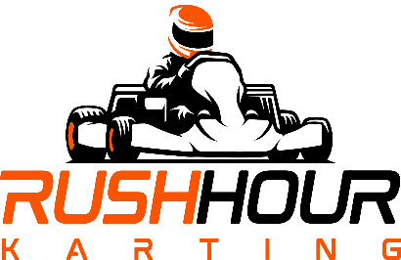
YOU are invited to a PARTY at Rush Hour Karting!!!
For: ____________________________________________

Date: _________________________________________ Time: _________________________

RSVP to: _______________________________________________________________________

Phone # ___________________________________ Email: ______________________________

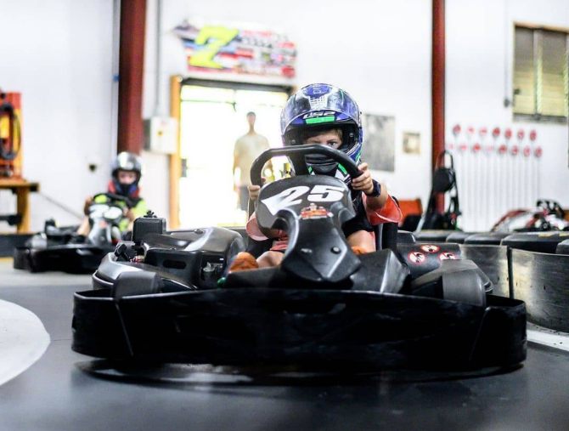
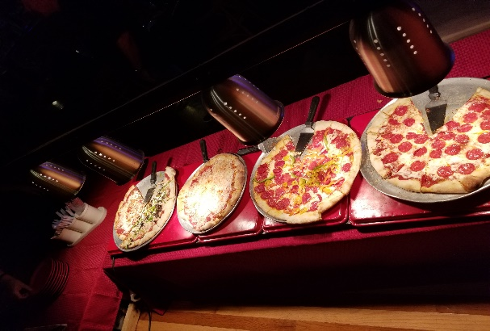
Rush Hour Karting is a High Speed, all Indoor Karting Facility. We have a 1/3 mile Road-Race Track, full of Hair-Pins, Straights, and Sweeping Curves. You jet around this course, with Karts that will go over 30 MPH!

Plus, we have Video Games, V.R., Rock Climbing, Ping Pong, & plenty more!

It is all indoor, so come Rain or Shine, the race will go on!

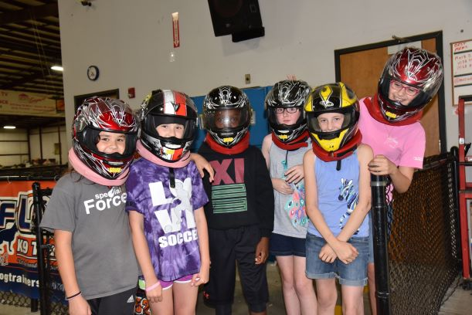
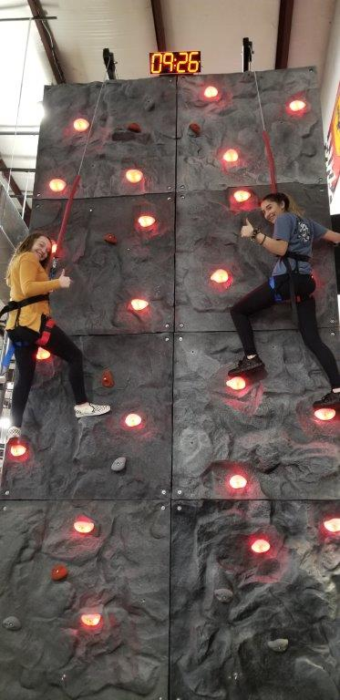
Along with the intense racing, all will eat like Champs in the Pizza Pit, overlooking the Race Track.
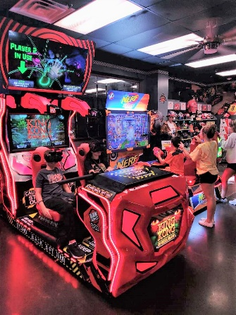
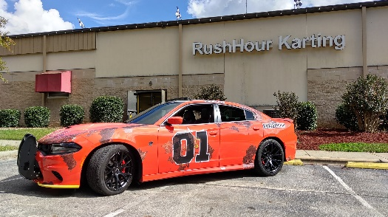
IMPORTANT NOTES:
- Please arrive on time for your party in order to participate!
- Please come prepared in closed-toe shoes.
- Juniors (ages 8 – 14) will race separate from Adults (ages 15 +)
- Waiver must be signed by Parent or Guardian. Please click here
to sign online: Self-Checkin Kiosk - Rush Hour Karting
White Oak Business Park
5335 Raynor Road
Garner, N.C. 27529

Ph (919) 662-9101
www.RHKfun.com
Rush Hour is very easy to get to:
- Take I-40 towards Garner
- Exit 306B “Hwy 7o” EAST
- Go Towards Clayton / Smithfield (NOT Garner)
- Right at the 1st Light – Raynor Rd (at Kangaroo Gas St.)
- 1 Mile Down, on Left – Rush Hour Karting

