YOU are invited to a PARTY at Rush Hour Karting!!!
For: ____________________________________________

Date: _________________________________________ Time: _________________________

RSVP to: _______________________________________________________________________

Phone # ___________________________________ Email: ______________________________
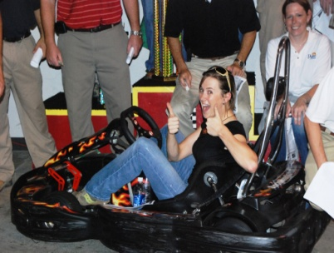
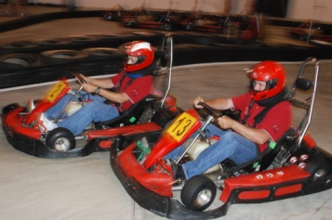
Rush Hour Karting is a High Speed, all Indoor Karting Facility. We have a 1/3 mile Road-Race Track, full of Hair-Pins, Straights, and Sweeping Curves. You jet around this course, with Karts that will go over 30 MPH!
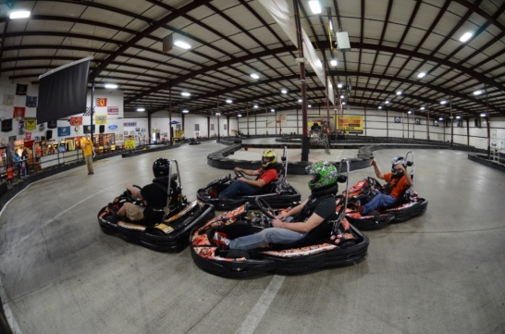
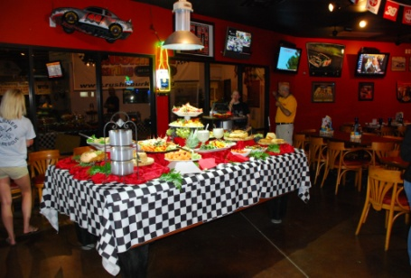
It is all indoor, so come Rain or Shine, the race will go on!

Along with the intense racing, all will eat like Champs in the Pizza Pit, overlooking the Race Track.

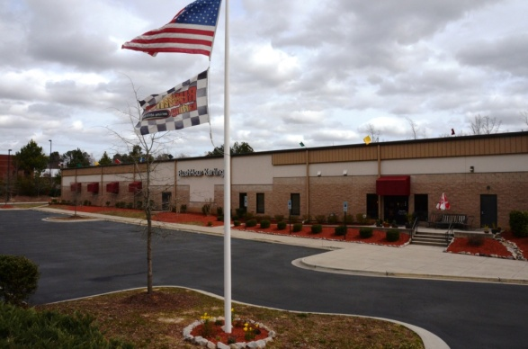
Rush Hour RTP is very easy to get to:
- Take I-40 towards Morrisville/RDU Airport
- Exit 285 Aviation Parkway
- Go Towards RTP, Lake Crabtree
- Turn Right at McCrimmon Pkwy
- Turn Right into Wake Competition Center - 1/2 Mile Down

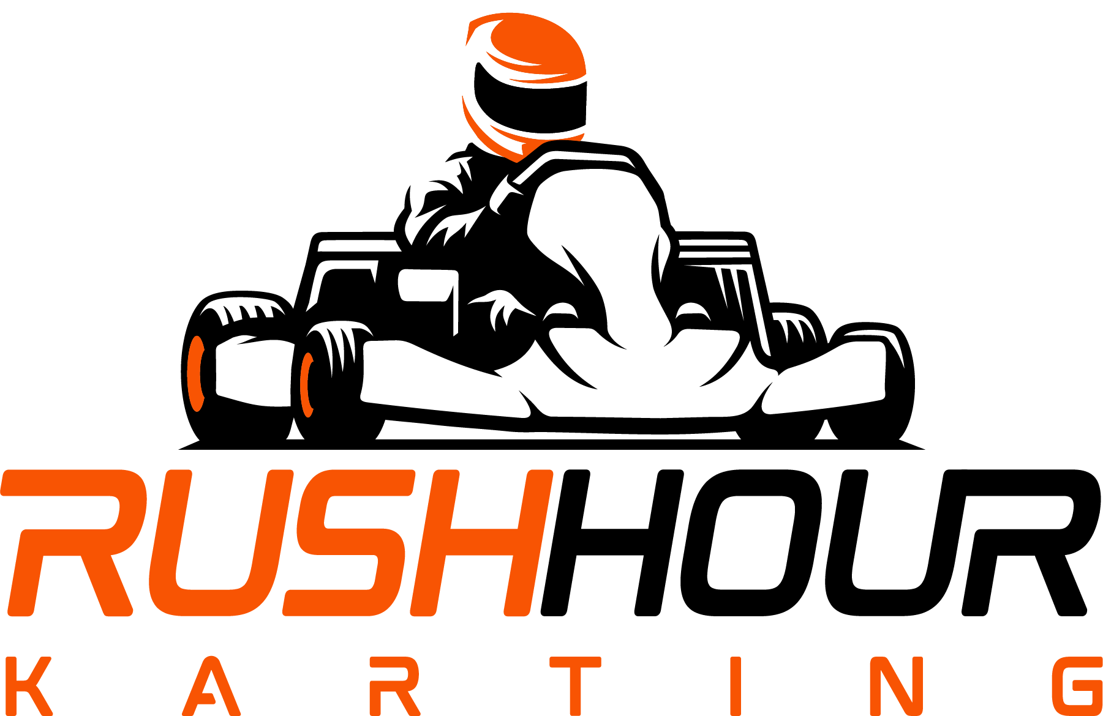
IMPORTANT NOTES:
- Please arrive on time for your party in order to participate!
- Please come prepared in closed-toe shoes.
- Must be Age 13+ to race
- Drivers MUST wear closed toe shoes; no sandals or flip flops!
- Waiver must be signed by Parent or Guardian for racers less than 18 years of age. Please click here to register drivers before you arrive: https://rushhourkarting.com/self-checkin-kiosk-rtp/
Inside Wake Competition Center
1021 WCC Lane
Morrisville, NC 27560

Ph (919) 439-5222
www.rushhourkarting.com

