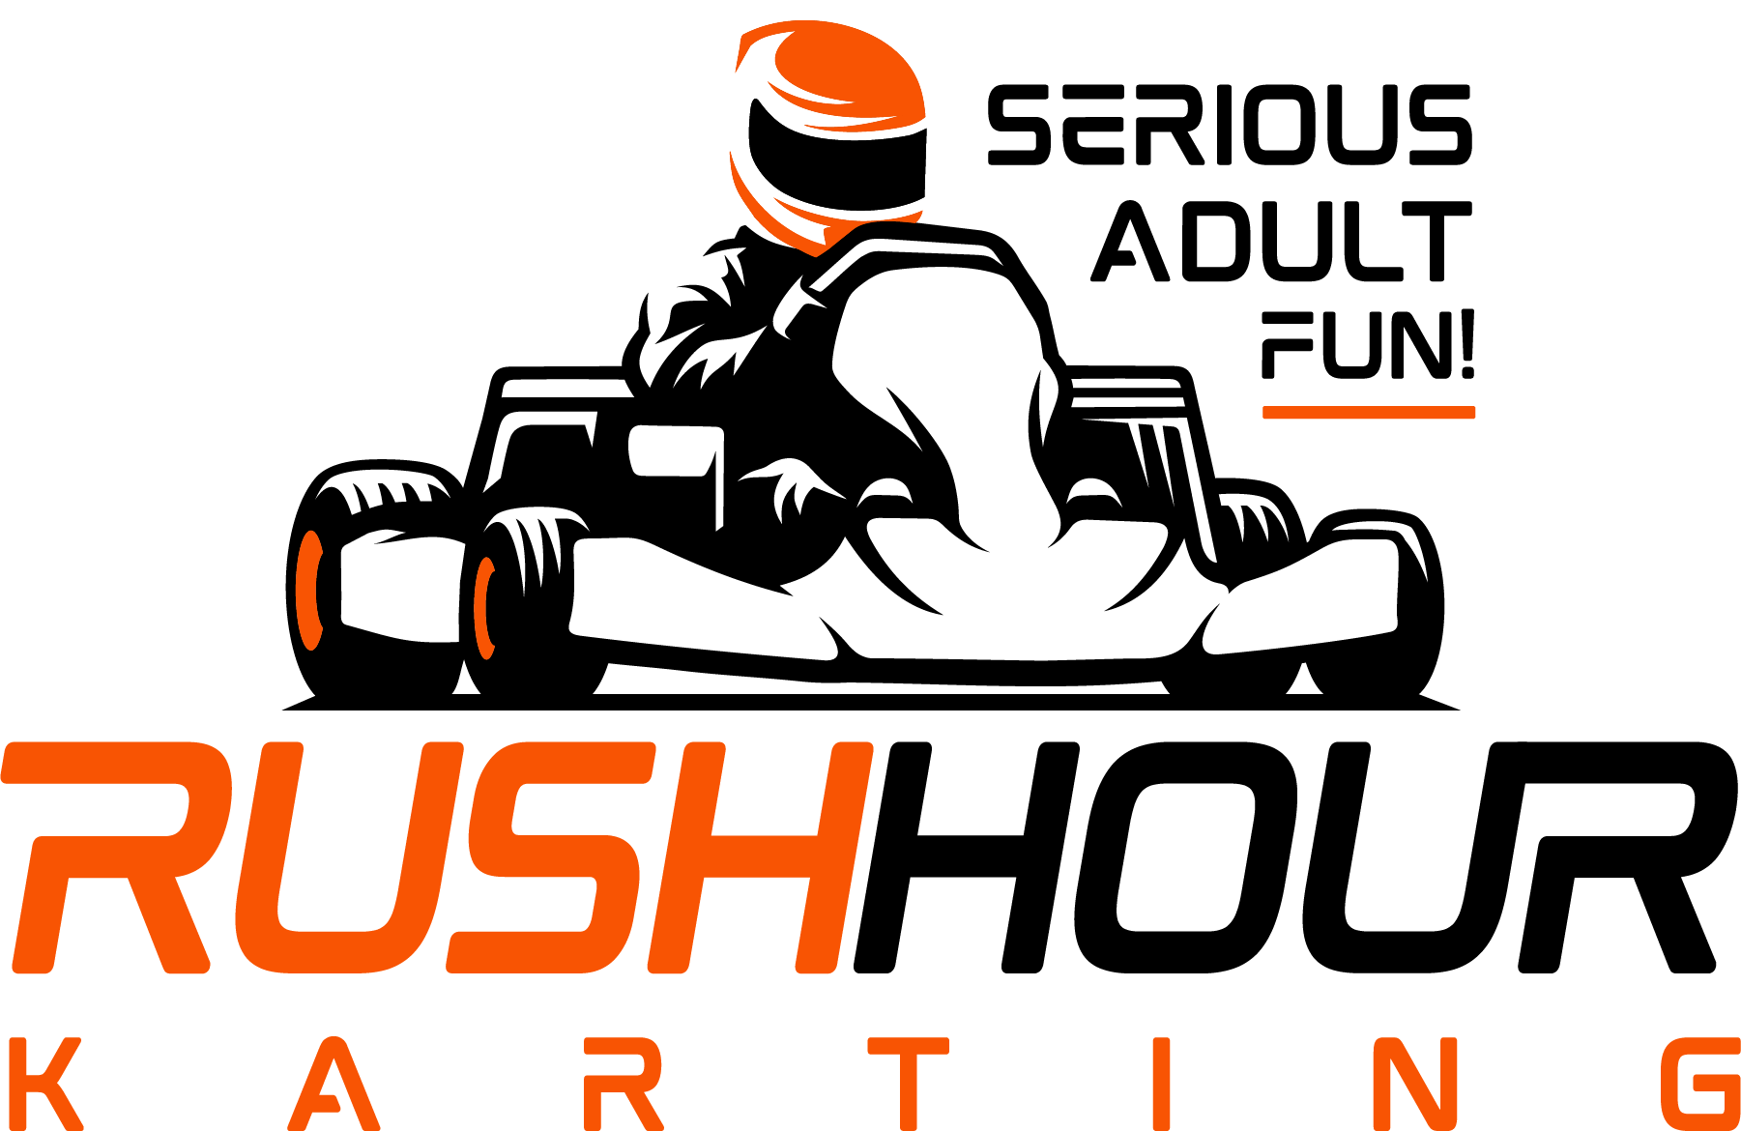
Wake Competition Center
1021 WCC Lane
Morrisville, NC 27560

Ph (919) 439-5222
www.RHKfun.com

RE: COMPANY OUTING & FUN!!!
Date:
Time:
For:
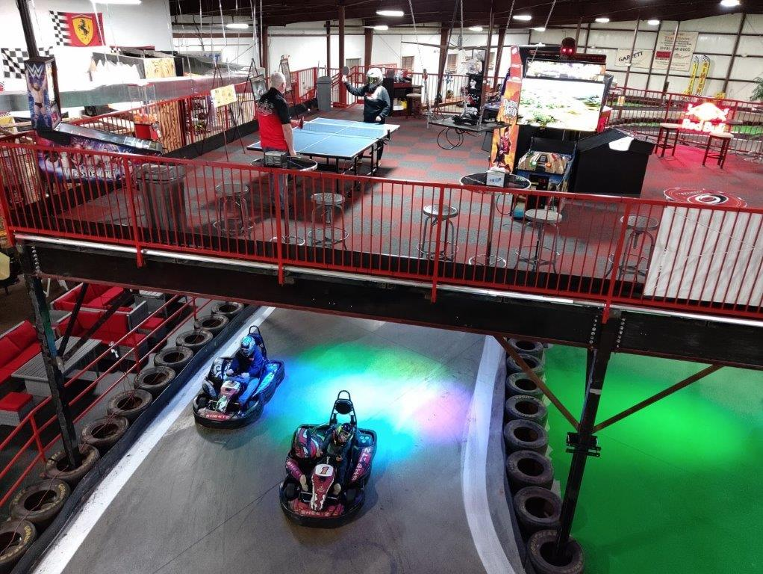
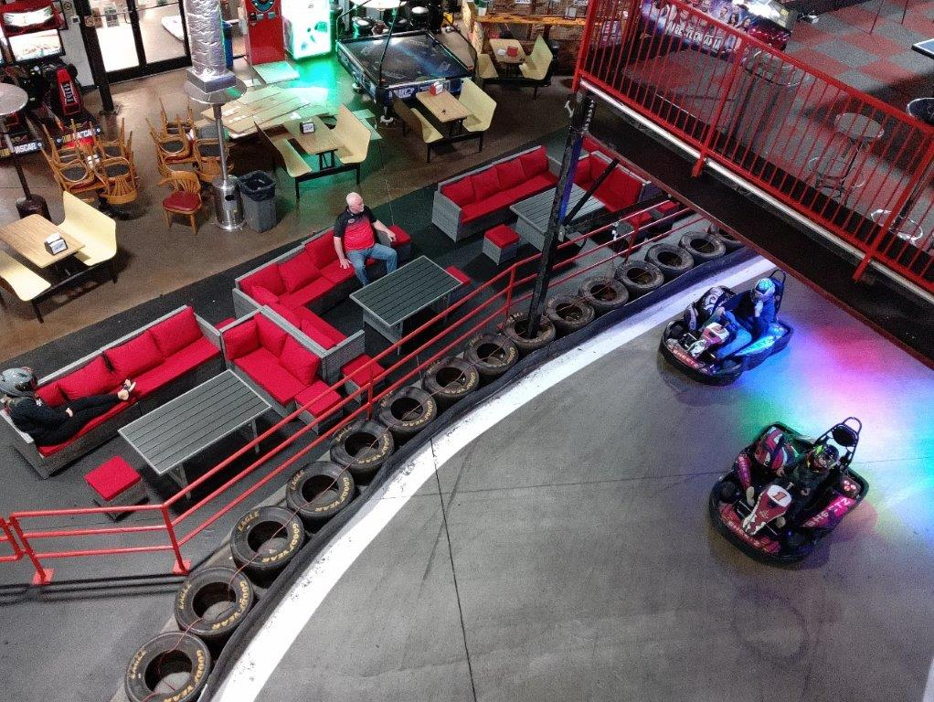
To:
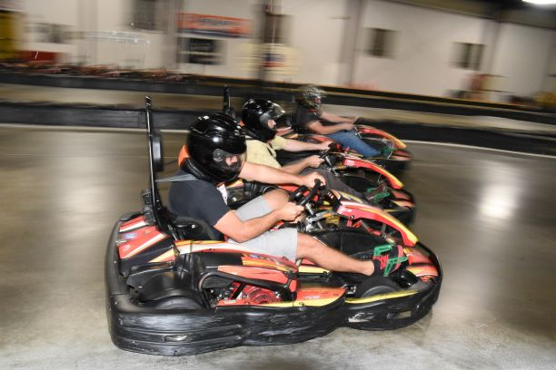
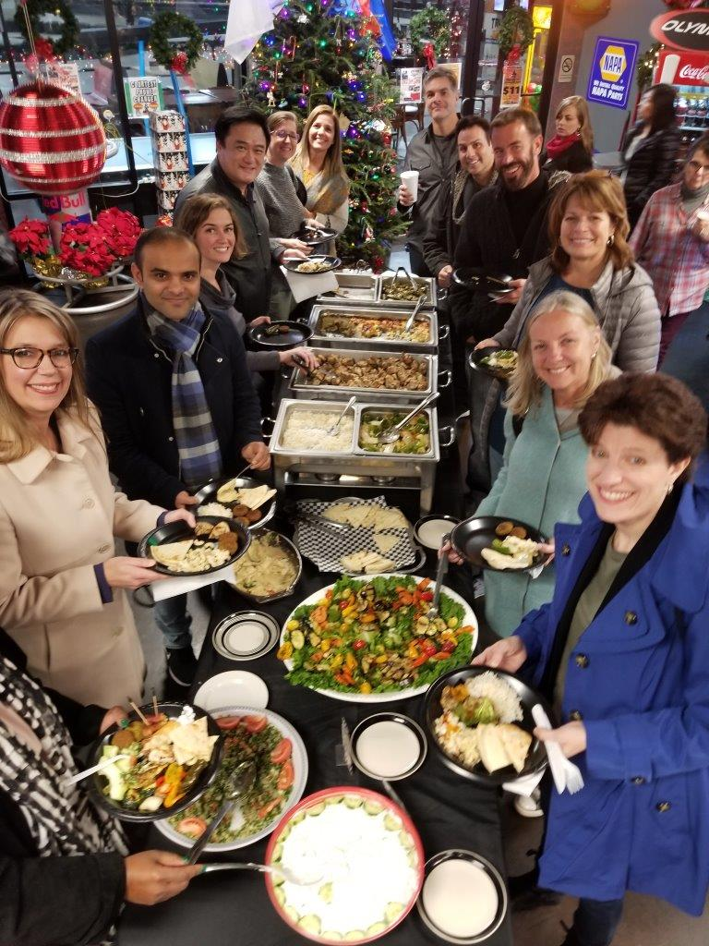
Rush Hour Karting is a High Speed, all Indoor Karting Facility. We have a 1/3 mile Road-Race Track, full of Hair-Pins, Straights, and Sweeping Curves. You jet around this course, with Karts that will go over 40 MPH!

It is all indoor, so come Rain or Shine, the race will go on.

Along with the intense racing, all will eat like Champs in the Sports Bar or the new Mezzanine, overlooking the Race Track. Scrumptious Buffet will be served, with drinks available.

In addition to racing, there are plenty of exciting activities:
- Latest & Greatest Video Games
- Axe throwing
- Golf Simulation Rooms
- Racing Sims
- WiFi available everywhere
- Giant TV ‘s for Sports watching
- Comfy & Cozy Cabana-style seating, trackside
- Awards podium, for trash-talking & picture-taking
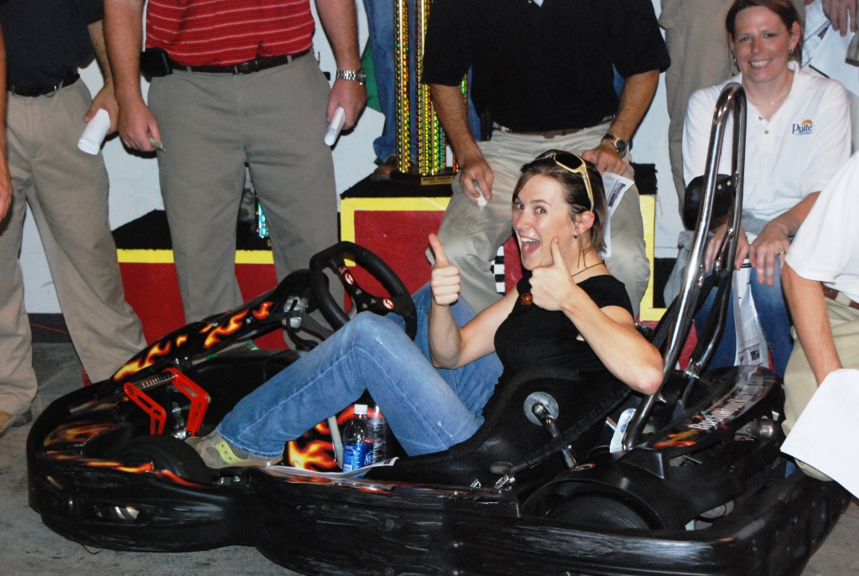
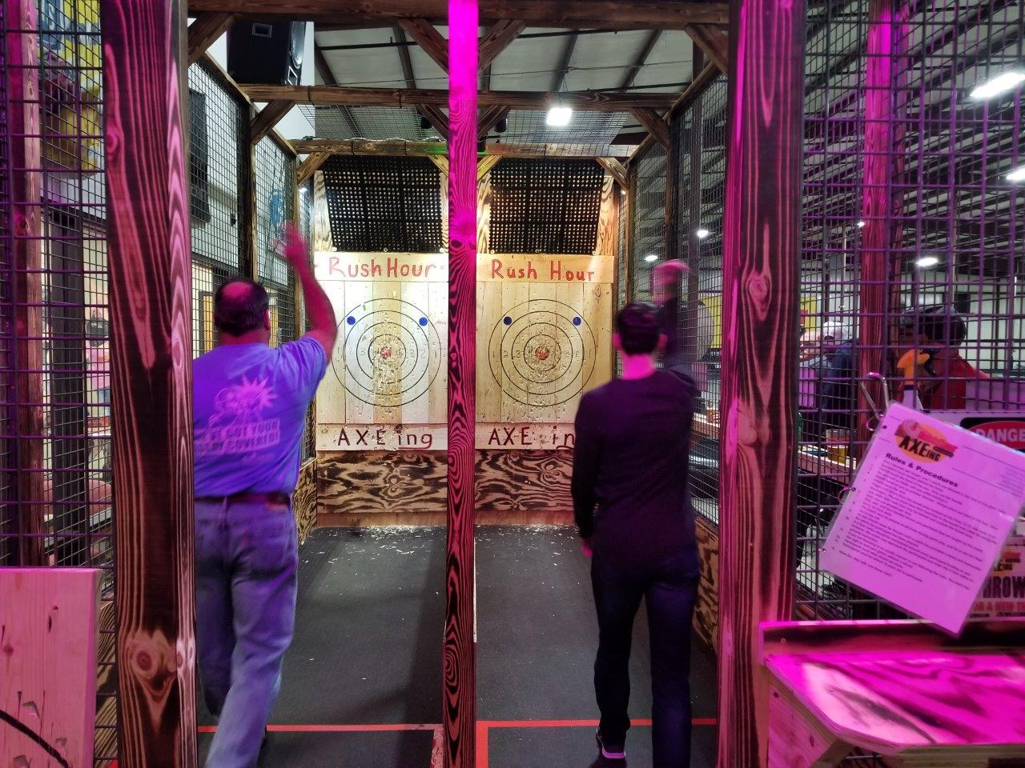

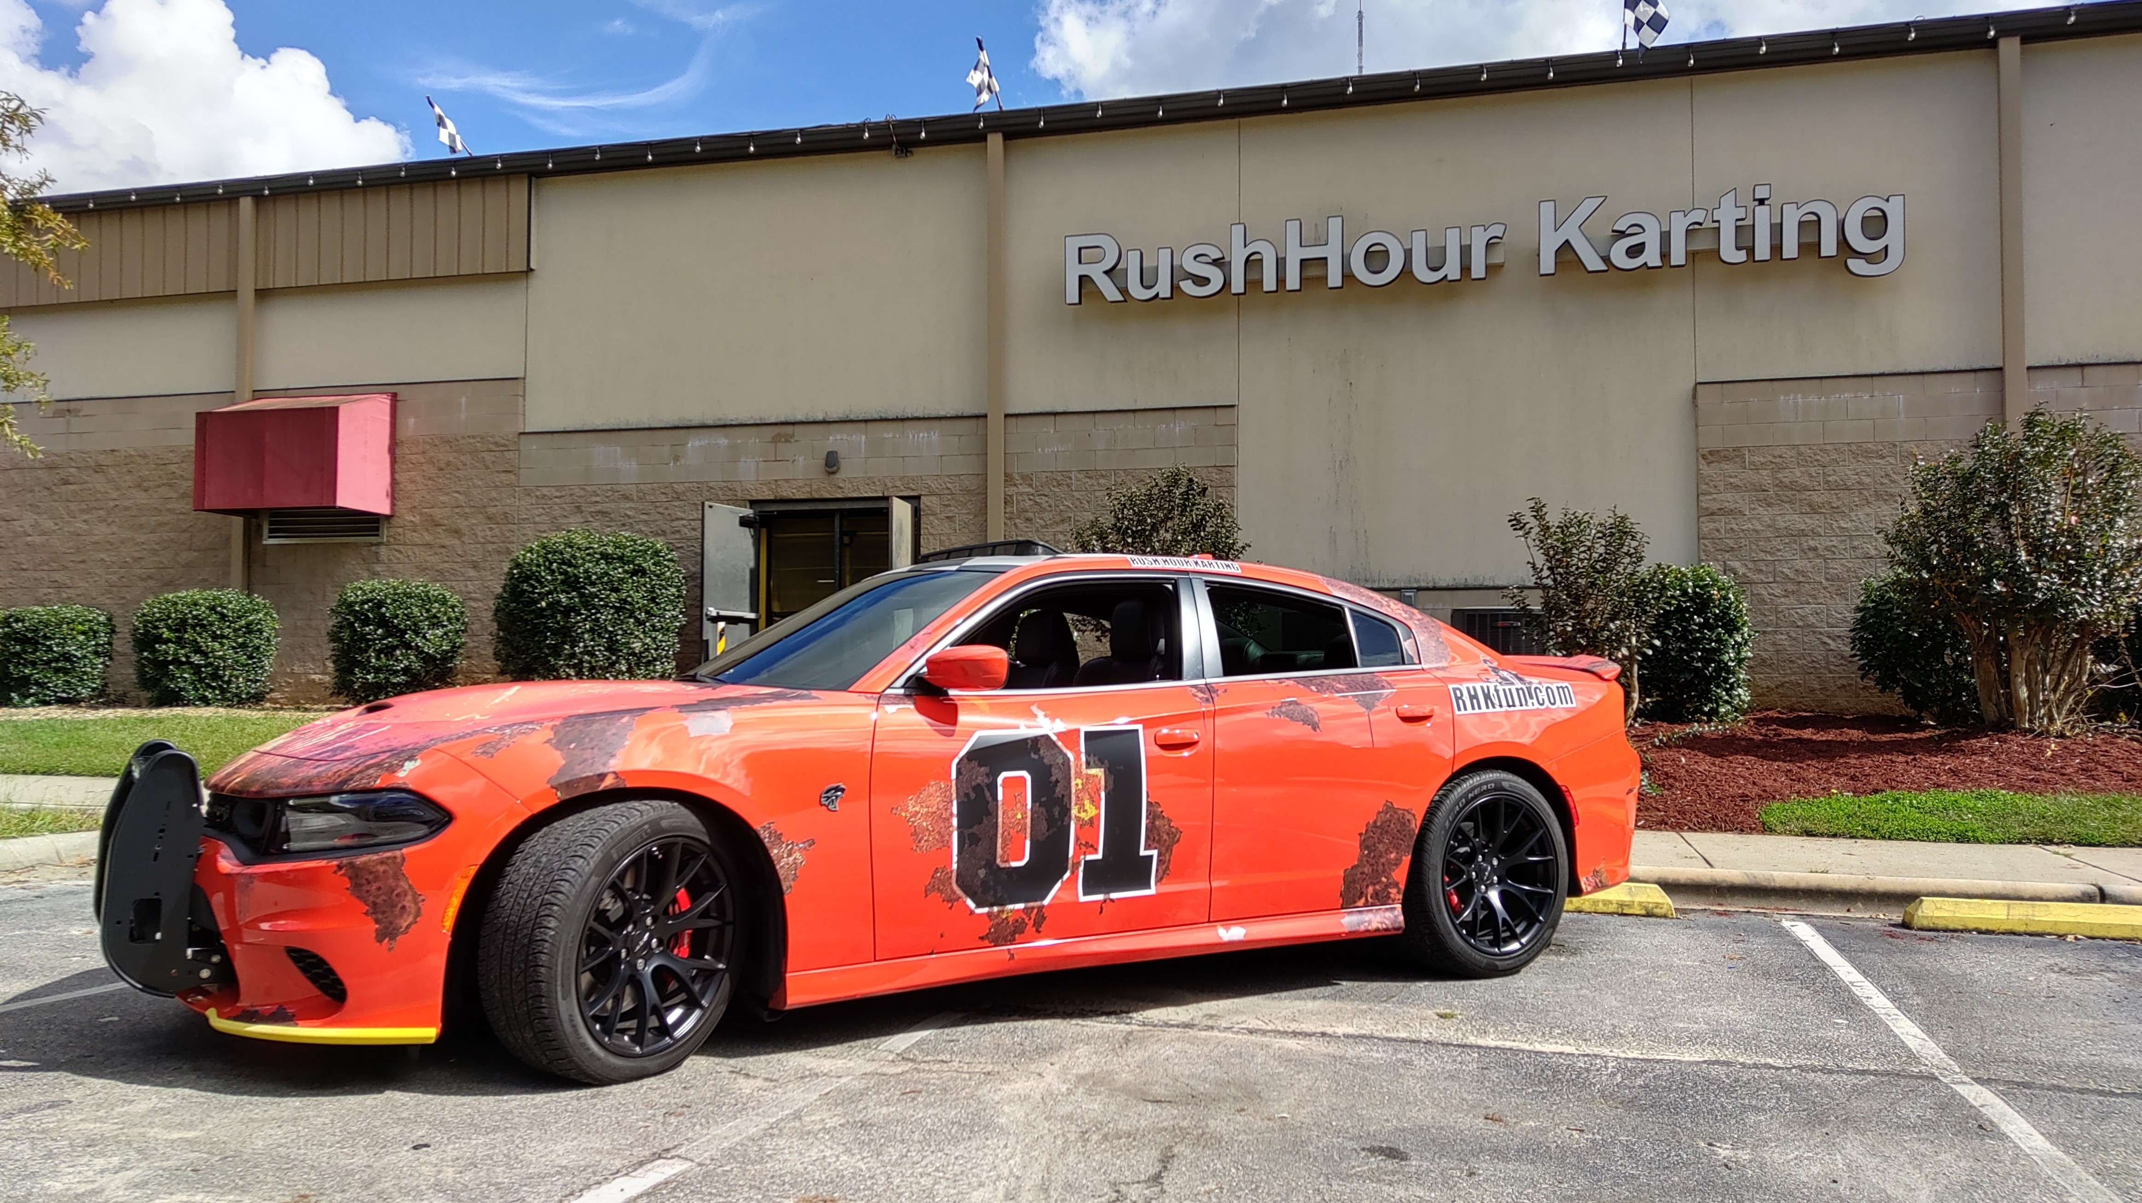
Rush Hour RTP is very easy to get to:
- Take I-40 towards Morrisville/RDU Airport
- Exit 285 Aviation Parkway
- Go Towards RTP, Lake Crabtree
- Turn Right at McCrimmon Pkwy
- Turn Right into Wake Competition Center - 1/2 Mile Down
We look forward to seeing you here!
Rush Hour is very easy to get to:
- Take I-40 towards Morrisville/RDU Airport
- Exit 285 Aviation Parkway
- Go Towards RTP, Lake Crabtree
- Turn Right at McCrimmon Pkwy
- Turn Right into Wake Competition Center - 1/2 Mile Down
Rush Hour is very easy to get to:
- Take I-40 towards Morrisville/RDU Airport
- Exit 285 Aviation Parkway
- Go Towards RTP, Lake Crabtree
- Turn Right at McCrimmon Pkwy
- Turn Right into Wake Competition Center - 1/2 Mile Down

